

**Automated Software Testing Fundamentals**

**(L/617/8670)**

**Learner Assessment  
Booklet**

**Learner Assessment Booklet**

**Level 4 Diploma in Software Testing**

**Unit:** Automated Software Testing Fundamentals

**Credit Value:** 16

**Unit Reference Number:** (L/617/8670)

***This form is used to record and confirm that assessment has taken place and the learner has achieved the unit detailed on pages 5 & 6***

|  |  |
| --- | --- |
| **Learner Name:** | Ryan McKee |
| **Assessor name:** |  |
| **Internal Verifier name:** |  |
| **Course:** |  |
| **Course code:** |  |
| **Completion Date:** |  |

|  |
| --- |
| **Achievement of unit is confirmed: Yes/No**  **Signature of Assessor:**  **Date:** |

|  |
| --- |
| **I certify that all the work in this booklet is my own.**  **Learner Signature:**  **Date:** |

**Assessment Grid: *Completed by Assessor***

|  |  |  |  |  |  |
| --- | --- | --- | --- | --- | --- |
| **Learning Outcomes** | **Achieved**  **(Delete)** | **Criteria** | **Booklet Page** | **Assessment Date**  **(If Applicable)** | **Date of Verification**  **(If Applicable)** |
| **1** | Yes | 1.1  1.2 |  |  |  |
| **2** | Yes/No | 2.1 - A  2.2  2.3 |  |  |  |
| **3** | Yes/No | 3.1 - W  3.2  3.3  3.4  3.5 |  |  |  |
| **4** | Yes/No | 4.1  4.2  4.3 |  |  |  |
| **5** | Yes/No | 5.1  5.2  5.3 |  |  |  |
| **6** | Yes | 6.1  6.2 |  |  |  |
| **7** | Yes/No | 7.1  7.2 |  |  |  |

***Note to Assessors:***

***This assessment record book is a template that you may choose to use to record summative assessment activities. It is intended to offer a framework for recording summative assessment. It is not intended to be prescriptive about assessment tasks. Assessors should amend the assessments and the booklet accordingly, taking account of the needs of their specific learner group and any opportunities for using combined assessments that cover multiple assessment criteria or learning outcomes.***

**Assessment record: *Completed by Assessor***

|  |
| --- |
| **Assessor Assessment decisions:** |

**Signature of Assessor:**

**Date:**

**All the following Learning Outcomes and Assessment Criteria MUST be met:**

**This unit has seven learning outcomes**

|  |  |
| --- | --- |
| **Learning Outcomes** | **Assessment Criteria** |
| **The learner will:** | **The learner can:** |
| 1. Understand what is meant by automated testing and its application. | * 1. Explain what is meant by test automation and the main two testing disciplines   2. Analyse at least three different features of web applications for which automated testing would be the optimal approach. |
| 1. Be able to research test automation practices in order to develop a software testing plan. | * 1. Research the advantages and disadvantages for test automation practices and their associated resources.   2. Critically compare the application of manual and automated software testing for a given application. – given application would be an api talk about some of the things that would need manually tested that api tests could not or selenium tests could now.   3. Develop an optimal software testing plan – need to show test plan for api test – do this for a website, get, post (add), put(update), delete and so on. Api test plan is in email theres no log. |
| 1. Be able to set up and use a web-based automated software testing tool. | * 1. Explain the setup procedures for using a web-based automated software-testing tool. – do this – needs work setting up rest assured   2. Explain Hyper Text Transfer Protocol (HTTP) and its ability to retrieve appropriate resources. – do this   3. Explain and demonstrate the use of at least four methods to assist the testing process available within a given testing tool. POST, PUT UPDATE AND DELETE screenshot the code for each of these and explain a bit about them.   4. Demonstrate the use of conditions to check for validity of tests   5. Demonstrate the effective use of a wait to assist with confirmation that a specific testing task has been successful. |

|  |  |
| --- | --- |
| **Learning Outcomes** | **Assessment Criteria** |
| **The learner will:** | **The learner can:** |
| 1. Be able to locate and test web elements. | * 1. Explain and demonstrate at least three different techniques to reference web elements on a webpage. – needs work got screen shots and stuff now show how I got it on the browser.   2. Explain what is meant by the Document Object Model (DOM) and how it allows a Hypertext Markup Language (HTML) webpage to be accessed. - The DOM is the entire script of the website you can look at when you inspect a web page. (DOM is everything that makes the page HTML, Javascipt libraries and so on.   3. Demonstrate the use of browser developer tools for testing. – needs to be done. |
| 1. Be able to manage and interact with notifications within a browser. | * 1. Critically evaluate different types of notifications and responses received from interactions within a browser. – responses are response codes, 200 working, 500, 400 so on. Evaluate the response code for something like a delete code where even tho 200 shows that the api works as expected but in the body it returns false telling the test an item was not actually deleted.   2. Summarise common exceptions and codes generated through different test actions. – exceptions that cause the exception codes shown above. Examples could be a connect exception thrown when a test is run.   3. Use an appropriate test strategy to effectively manage and interact with a new tab or window. – selenium pop up tests notes in email |
| 1. Be able to research and create a test automation suite.   “ A test suite is just several different classes testing classes within a software solution “ | * 1. Research and evaluate the advantages and disadvantages of implementing a test suite.   2. Create a test automation suite for use with multiple test cases for test execution purposes. |
| 1. Be able to research and create a test automation framework. | * 1. Research and evaluate the advantages and disadvantages of using a test automation framework. – can do this as its just theory. 6.1 and 7.1 are sort of interlinked   2. Create a basic test automation framework for a given application that features reusability of code and low-cost maintenance. – can’t look at this currently complete after easter. |

**ASSESSMENT CRITERIA (AC)**

**AC 1.1:** Explain what is meant by test automation and the main two testing disciplines.

Test automation refers to the use of software tools to execute tests automatically, without requiring manual intervention. Test automation is particularly useful for repetitive tests, where manual testing would be time-consuming and error prone. There are two main disciplines withing test automation the first being functional testing which involves testing whether the system or software application is functioning as expected, by verifying its behaviour against a set of predefined requirements. Functional testing includes testing individual functions or features of the system or software application, as well as testing the overall behaviour of the system examples of functional tests would be smoke testing, regression testing, integration testing unit testing, alpha and beta testing and user acceptance testing just to name a few.

The second method of automation testing is non-functional testing this is when non-functional aspects of the system or software application, such as performance, reliability, scalability and security. Are tested. Non-functional testing focuses on the systems’ ability to meet performance requirements, handle varying loads, and function effectively and securely in different environments. Some examples of non-functional tests include performance tests, load tests stress tests and security tests.

Overall test automation can be applied to both functional and non-functional testing disciplines. Automating tests can significantly reduce the time and effort required to perform tests, while also improved their accuracy and repeatability.

**AC 1.2:** Analyse at least three different features of web applications for which automated testing would be the optimal approach.

Automated testing has become an indispensable practice in modern web application development as it helps to ensure that software meets its requirements and operates as expected. There are several features of web applications where automated testing is optimal, including UI testing, API testing, and performance testing.

Automated UI testing is an optimal approach for web applications that have a large user interface, such as e-commerce sites, content management systems, and social media platforms. The user interface is a critical aspect of web applications as it's the primary way users interact with them. Automated UI testing frameworks, such as Selenium, can simulate user interactions and verify the expected output against the actual output. This can help to ensure that the application's interface is functioning as expected and is responsive to user interactions.

Web applications are often built using APIs, which expose data and functionality to other applications. Automated API testing is optimal for applications that rely heavily on APIs, such as those with complex data structures, multiple endpoints, or those that integrate with third-party APIs. Automated API testing can verify that the API endpoints return the expected response and that the response is correctly formatted. It can also ensure that the API performs as expected under varying loads and network conditions. Tools such as Postman or Newman can be used to automate API testing.

Web applications must perform well to provide a satisfactory user experience. Automated performance testing is optimal for web applications that have high traffic and a large user base, such as e-commerce sites, social media platforms, or video streaming services. Automated performance testing can help to ensure that the application can handle the expected load and is responsive under varying traffic and network conditions. Tools such as JMeter can be used to simulate traffic and measure performance metrics like response times, throughput, and error rates.

In conclusion, automated testing is essential for ensuring the quality and performance of web applications. UI testing, API testing, and performance testing are three critical areas where automated testing can be an optimal approach to achieving quality and reliability in web application development. By incorporating automated testing into the development process, web developers can minimize the risk of errors and ensure that their applications meet user requirements and provide a satisfactory user experience.

**Section 2**

**AC 2.1:** Research the advantages and disadvantages for test automation practices and their associated resources – need to talk about resource not sure what is expected for this if it’s the libraries used for test automation or what.

Test automation is a widely adopted practice in the software industry due to its numerous advantages, but it also comes with several drawbacks. Therefore, it is crucial to evaluate the pros and cons before implementing automation. One of the primary benefits of automation is its ability to enhance testing speed and efficiency compared to manual testing. Automated tests can run repeatedly and consistently without human error, offering prompt feedback on whether the application functions correctly. Besides, it facilitates comprehensive test coverage by enabling easier testing of various scenarios and edge cases. This, in turn, ensures thorough testing and the detection of potential issues early in the development cycle, reducing the overall cost of testing and preventing costly production errors. Furthermore, automated tests can be integrated into continuous integration processes, leading to automatic and quick testing of code changes, minimizing the possibility of regressions and ensuring the application remains stable.

However, despite these benefits, test automation has several disadvantages. Firstly, it involves a significant initial investment in developing and maintaining automated tests, which can be costly. Additionally, automation requires specialized skills that may not be available in-house, necessitating additional resources and expertise. Secondly, not all tests can be automated, particularly those that require human intuition and creativity, such as usability or exploratory testing. Consequently, manual testing is still necessary in some scenarios. Thirdly, automated tests require maintenance, like any other code, to remain relevant as the application evolves, which can be time-consuming and require additional resources. Fourthly, automated tests can report false positives, leading to frustration among developers and testers and reducing confidence in the automated testing process. Finally, automated tests can only test what they are programmed to test, potentially missing issues that a human tester would notice. Therefore, it is essential to supplement automated testing with other methods to ensure comprehensive testing of the application.

**AC 2.2:** Critically compare the application of manual and automated software testing for a given application – need to apply this to a given application. Staff api talk about how sometimes there are certain tests can could not be automated or is not worth automating as it would be easier to manually test it instead. Could all those endpoints be automated for staff API. Yes, in this case because all the end points can be tested but for an application like a website there may be some tests which would be best manual to ensure a high quality user experience. Talk about what end points could be automated post/put/get/delete.

Manual testing and automated testing are two primary methods of software testing. Both methods have their advantages and disadvantages, and the choice of which one to use depends on various factors such as the nature of the application, the level of testing required, the time and budget constraints, and the availability of resources. Manual testing involves a tester executing test cases manually, without the use of any automated tools. The tester simulates user actions to ensure that the application behaves as expected. Manual testing requires a skilled tester who can identify defects that an automated tool may miss. Manual testing is useful when the application's user interface is complex or when the application has many different test cases that are difficult to automate. One of the advantages of manual testing is that since it is performed by a human, it can identify issues that may be missed by automated testing tools, making it more thorough. Another advantage is that it is less expensive than automated testing since it does not require the use of specialized tools or equipment. Manual testing is also useful when testers need to perform ad-hoc testing or exploratory testing to uncover hidden defects. However, manual testing can be time-consuming, especially when testing large or complex applications. It is not scalable as it requires additional resources and time for each new test case, and it is subject to the tester's bias, which can lead to non-repeatable results. Automated testing involves using specialized tools to execute test cases automatically. Automated testing can save time and effort, and it can be useful for testing complex or repetitive tasks. Automated testing is suitable when the application has many test cases that are well-defined and repeatable. One of the advantages of automated testing is that it can save time and effort since it can execute test cases much faster than a human tester. It is also scalable, as it can execute many test cases in a short period. Additionally, it is more repeatable than manual testing since the same tests can be executed multiple times with consistent results. However, automated testing requires specialized skills to develop and maintain automated test scripts. It can have a high initial cost for acquiring and setting up the necessary tools and equipment, and it may not be effective in identifying defects that require human judgment, such as visual defects or usability issues. In conclusion, the choice of manual or automated testing for a given application depends on various factors, including the application's complexity, the level of testing required, and the available resources. Manual testing is better suited for ad-hoc testing and complex user interfaces, while automated testing is more appropriate for repeatable tasks and scalable testing. Ultimately, a combination of both manual and automated testing may provide the most effective testing approach. It is essential to consider the advantages and disadvantages of each method to make an informed decision that meets the needs of the specific application being tested.

**AC-2.3:** Develop an optimal software testing plan

Below shows a test plan for the staff spring boot api covering all CRUD endpoints for this API:

**Section 3**

**AC 3.1:** Explain the setup procedures for using a web-based automated software-testing tool

This step involves creating a new Maven project, which is relatively simple to accomplish in most IDEs. A Maven project provides a structured and standardized approach to software development and is widely used in Java-based web applications.

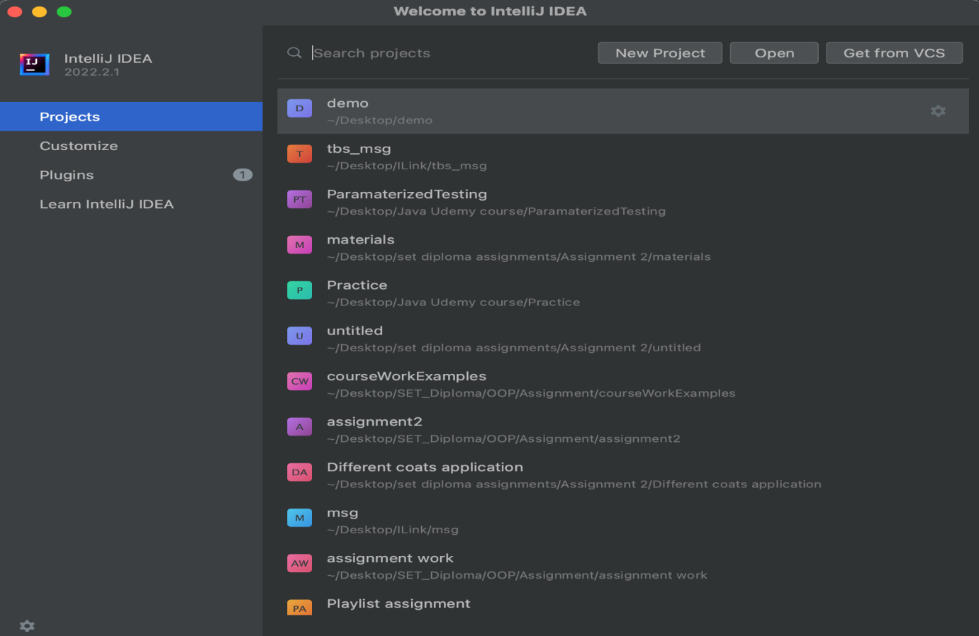

Input the name of your testing application, select the JDK version, and choose the appropriate Archetype from the available templates. 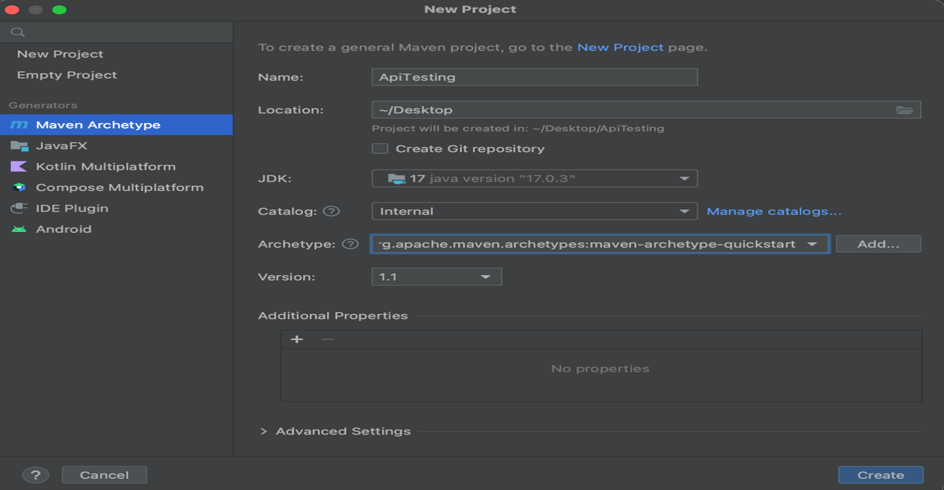In this step, you will specify the name of your testing application and select the version of the Java Development Kit (JDK) you wish to use. Additionally, you will choose an Archetype, which is a collection of pre-defined templates that provide a starting point for your project. This selection determines the structure and dependencies of your project. Ensure that you choose the appropriate Archetype that suits your project requirements.

Once you have completed Step 2, your project will open up, and Maven will automatically begin generating the project based on the templates defined in the pom.xml file.

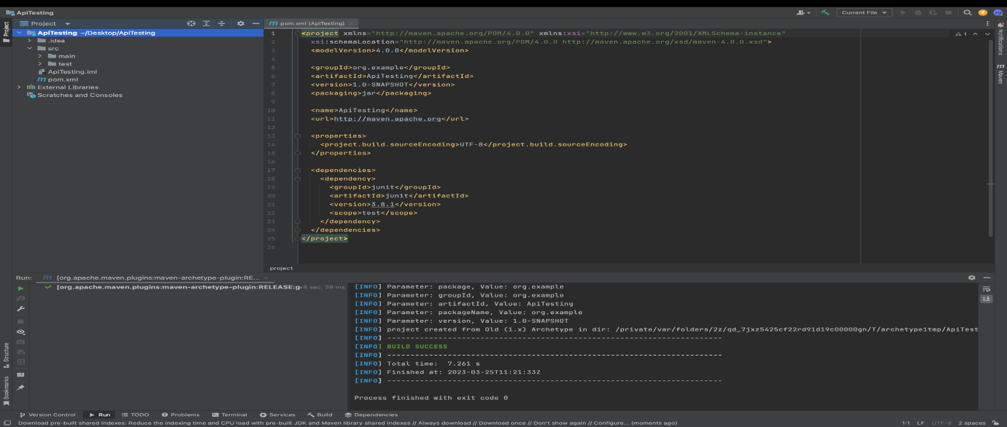At this point, the project structure and dependencies are defined, and Maven is configuring the project based on the selected Archetype. The pom.xml file is a configuration file that defines the project's build process, dependencies, and other details. Maven uses this file to manage the project's build and deployment process. With the project generation underway, proceed to the next step.

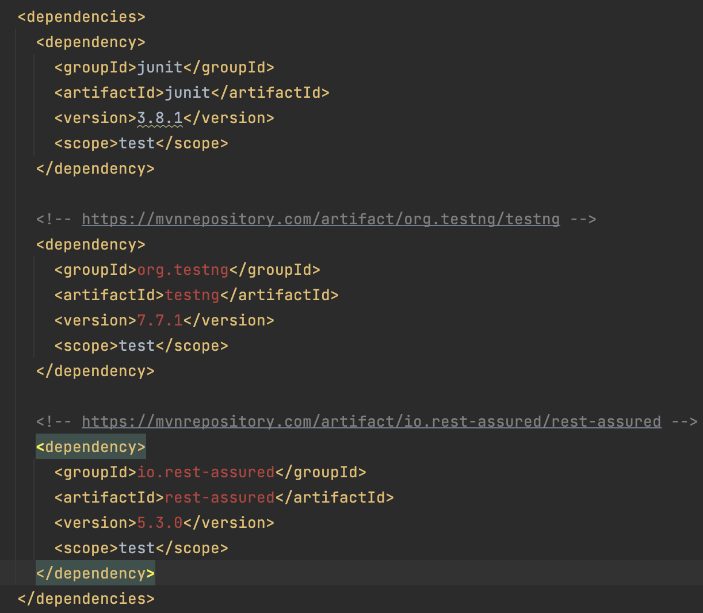In this step, you will add import statements for the libraries required by your test automation project to the dependencies section of the pom.xml file. These libraries include Rest Assured and TestNG, which are essential for implementing automated tests in web applications. By adding these libraries to the project, you can leverage their functionality in your test scripts. Ensure that the import statements are correctly formatted and located within the dependencies section of the pom.xml file.

Click install and maven will install these new project dependencies.

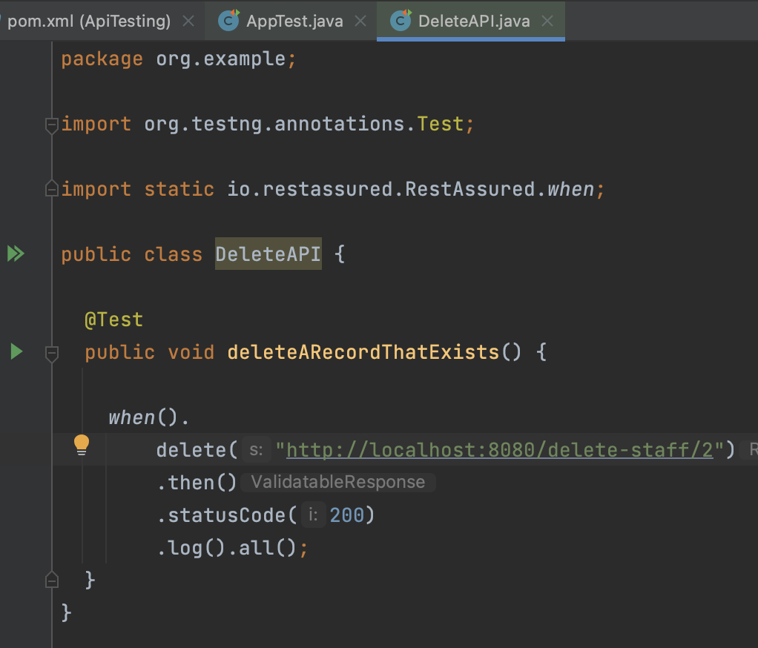With the project dependencies in place, you can now create your API test. Below is an example of a Rest Assured test that checks the response when a delete function occurs on the localhost.

**AC 3.2: Explain Hyper Text Transfer Protocol (HTTP) and its ability to retrieve appropriate resources.**

Hyper test transfer protocol (HTTP) is a protocol used for communication between web servers and clients, such as web browsers. The HTTP protocol governs how requests from clients are made to the server, and how the server responds to those requests with the appropriate resources like HTML pages, images, documents videos and audio files and web services.

HTTP uses uniform resource locators (URLs) to identify resources on the web. A URL is a unique address that identifies a resource such as a web page, image or document. The URL consists of a protocol (http:// or https://), a domain name example.com which will translate to the physical address e.g. 198.102.434.8 and a path to the resource on the server e.g. ( /documents/foo )

HTTP requests can be made using several different methods. The most common HTTP methods are GET, POST, PUT or DELETE.

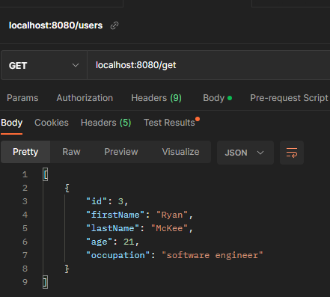Get: This method is used to retrieve a resource from the server. When a client sends a GET request to a server, the server response by sending the requested resource back to the client. GET requests can be cached by clients and servers, making them useful for retrieving resources that do not change frequently.

Figure : The image on the left shows an example of a get request for a localhost server which gets a staffs details. The resource is returned in JSON format.

POST: This method is used to submit data to the server. When a client sends a POST request to a server, it typically includes data in the request body that the server can use to perform some action, such as updating a database. Post requests are not cached by clients of servers, making them useful for submitting data that should not be cached.

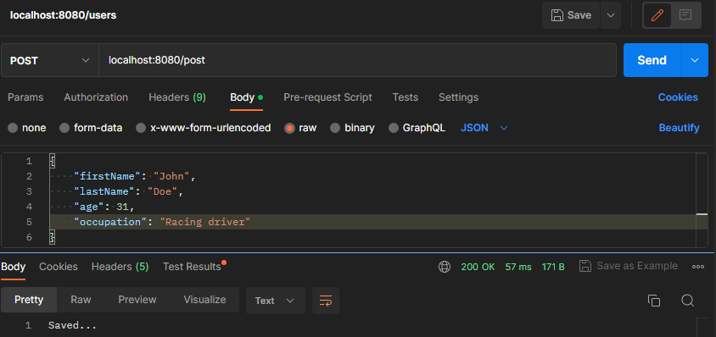

Figure : Above shows an example of a POST request. When endpoint /post is used the information in json format in the request body is sent to the server this is confirmed by the response body at the bottom returning the string saved and the status code 200 on the bottom right in green.

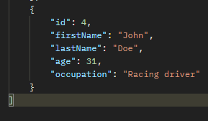PUT: This method is used to update an existing resource on the server. When a client sends a PUT request to a server, it typically includes the updated data in the request body, and the server updates the resource with the new data. PUT requests can be used to create new resources as well, if the server supports this.

Above shows the record with id 4 before the PUT operation was performed.

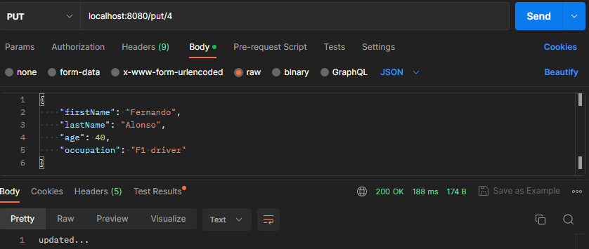

Figure : Above shows and example of the end point put which also takes the id of the record that is being updated. In this example the record with id 4 is updated to contain the information sent in the message body. Below is the output of that update.

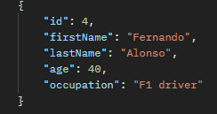

DELETE: This method is used to delete a resource from the server. When a client sends a DELETE request to a server, the server deletes the resource and responds with a confirmation message. DELETE requests can be used to remove resources that are no longer needed.

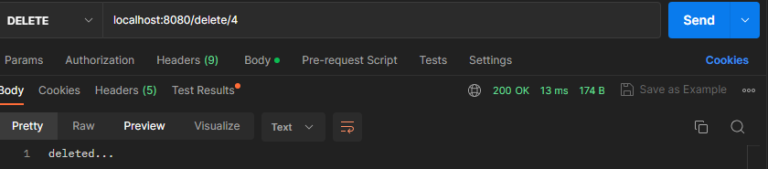

Figure : Above shows an example of the delete end point it takes a path variable and as long as there is a record in the database with this id the record will be deleted as shown in the example above.

In summary, HTTP is a protocol that allows clients and servers to communicate and exchange resources. HTTP request can be made using different methods (verbs) such as GET, POST, PUT, and DELETE, each serving a different purpose in retrieving and manipulating resources on the server.

**AC 3.3: Explain and demonstrate the use of at least four methods to assist the testing process available within a given testing tool. POST, PUT UPDATE AND DELETE screenshot the code for each of these and explain a bit about them.**

When testing an API, it is crucial to create a test suite that covers all its functionalities. We can automate these tests using TestNG as the testing library and Rest Assured, which provides a DSL for testing RESTful APIs like the one in the example. Rest Assured allows for tests to be written in a simple and readable manner, making it easier to validate the API's functionality. It is a Java library that offers a DSL specifically for testing RESTful APIs.

**GET test**

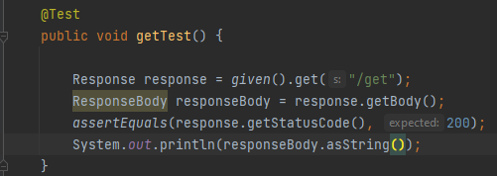

Figure : Above is a GET test that checks if the /get endpoint returns a status code of 200, indicating that the request was successfully received, understood, and accepted by the server. This means that the server has processed the request and is returning the requested information to the client in the message body of the response. To ensure that the response body is not null, the test prints it to the console manually.

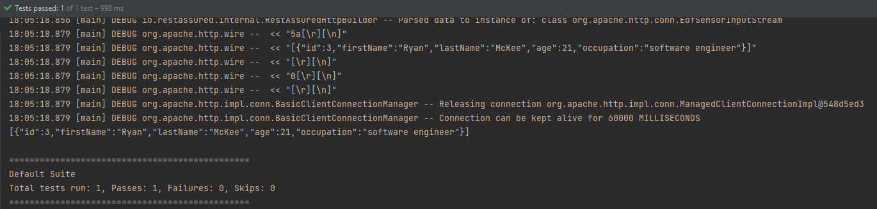

Figure 6: Above is the console output after running the getTest. It displays the returned response body and confirms that the test has passed.

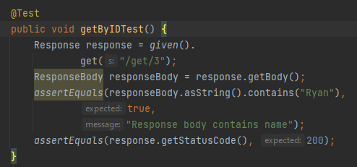

Figure : Above is another example of a GET request, this time using a different endpoint that takes a specific ID of a staff member (in this case, number 3). The test checks if the response body contains "Ryan" (to confirm that this is the expected staff member) and if the status code is 200, indicating a successful response.

**PUT test**

Figure : This is an example of a PUT test function. It checks if sending employee data in JSON format via the request body to the /update-staff/4 endpoint results in a successful request with a status code of 200.

**POST test**

Figure : This is an example of a POST REST test function. The function checks if, when using the /add-new-staff-member endpoint and passing an employee's details in JSON format in the request body, the response code is 200 and the size of the employee list has incremented by 1.

**DELETE TEST**

Figure : This code contains a unit test for the delete-member-endpoint. The test will fail if there are no records in the database, as it requires at least one record to be present. The test retrieves the ID of the last record in the database using a GET request, and then calls the delebeByIdAndGetResponse function to delete the record using this ID. It checks the response code to ensure that it is 200, indicating that the delete was successful, and also verifies that the database size has decreased by 1.

Figure : This function is used in the test function shown in Figure 7. It takes an ID as an argument and uses a REST Assured DELETE statement to call the “/delete-staff-member/” endpoint, with the ID given as a path parameter.

**AC 3.4: Demonstrate the use of conditions to check for validity of tests – use ham-crest matchers for the conditions.**

**AC 3.5: Demonstrate the effective use of a wait to assist with confirmation that a specific testing task has been successful. This will be looked at next week but this is also a hamcrest function. – this function checks if the response time is too long you check how long the response takes to be received.**

**Section 4**

**AC 4.1: Explain and demonstrate at least three different techniques to reference web elements on a webpage**

Below contains a number of methods for locating and manipulating specific elements like buttons links and, forms and other interactive elements on a web page using unique identifiers.

Element ID

Referencing the element ID, a web automation tool or test script can easily interact with the targeted element, such as clicking a button, filling in a form field, or validating its content. This method is widely used approach in web automation and testing and is supported by most web automation frameworks and libraries like selenium.

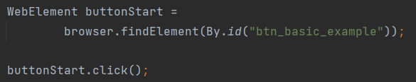

Tag names

This is a method of referencing a group of elements on a web page based on their HTML tag name. HTML tags are used to structure and define the content of a web page, and each tag has a specific purpose such as defining headings, paragraphs, lists and other elements This method is useful when the specific element ID or class is not available or when interacting with a group of elements that share the same characteristics. However, it may not be as precise as other methods since multiple elements can have the same tag name, and it may require additional filtering or validation to ensure the correct element is targeted.

XPath

Referencing a web element by XPath is a method of locating and manipulating specific web element on a web page using its XML path. XPath is a language used to query and navigate XML documents, including HTML pages, and can be used to locate specific elements based on their attributes, text content, or relative position within the HTML hierarchy. By using XPath expressions, a web automation tool or test script. XPath provides a powerful and flexible method for referencing web elements and is widely used in web automation and testing. However, XPath expressions can be complex and may require additional validation to ensure the correct element is targeted, and changes to the HTML structure may require updates to the XPath expressions.



**AC 4.2: Explain what is meant by the Document Object Model (DOM) and how it allows a Hypertext Markup Language (HTML) webpage to be accessed. )** Should show examples in photos

The document object model is a programming interface for web documents that allows scripts to dynamically access and manipulate the content, structure, and style of a hypertext markup language (HTML) webpage. The DOM represents the webpage as a hierarchical tree structure of objects, where each element, attribute, and text node is represented as a node in the tree. The DOM provides a way for scripts to traverse and manipulate this tree structure, allowing them to interact with the webpage’s content and behaviour.

To access an HTML webpage using the DOM, a web browser loads the page and parses its HTML code to create a DOM tree that represents the page’s structure and content. The DOM tree can then be accessed and manipulated using JavaScript or other programming languages, allowing developers to modify the content, style and behaviour of the webpage dynamically. For example, a script can use the DOM to add and or remove elements, change the style of content of an element, ore respond to user events such as clicks or keystrokes. The DOM provides a powerful and flexible way to interact with webpages and is widely used to web development and testing.

**A.C 4.3: Demonstrate the use of browser developer tools for testing – need to show some examples of testing including screenshots. Show examples of developer toolds gor aapi tests and such test the website functions and what not. Inspect elements for look for locators for selenium for example.**

Browser developer tools are essential for testing web applications. There are several tools that can be utilized to aid testing some of these examples are shown below.

* Inspect HTML and CSS: The developer tools allow you to inspect and manipulate the HTML and CSS of a web page. This can be useful for identifying layout issues, checking the box model, and testing responsive design.
* Debug JavaScript: You can use the console to debug JavaScript code. This can be useful for identifying errors and testing the behaviour of your code.
* Network analysis: You can use the network tab to analyse network traffic, including requests and responses. This can be useful for identifying slow loading resources and checking for errors in HTTP requests.
* Testing mobile views: The developer tools allow you to simulate different screen sizes and resolutions, which can be useful for testing how your website looks on different devices.
* Testing user interactions: You can use the develop9er tools to simulate used interactions, such as clicks and scrolls. This can be useful for testing the functionality of your website.
* Performance testing: You can use the performance tab to analyse the performance of your website, including page load times, resource loading ,and network activity.
* Accessibility testing: The developer tools have built-in accessibility auditing tools that can be used to test the accessibility of your website, including checking for keyboard navigation and screen reader support.

Overall browser developer tools are a powerful resource for testing web applications, and their many features can help developers ensure that their websites are running smoothly and efficiently.

**AC 5.1: Critically evaluate different types of notifications and responses received from interactions within a browser** – responses are response codes, 200 working, 500, 400 so on. Evaluate the response code for something like a delete code where even tho 200 shows that the api works as expected but in the body it returns false telling the test an item was not actually deleted. Show a few sample responses

HTTP protocol is used to communicate with a web browser and HTTP response status codes are sent in response to a message sent to a browser. There are several types of response codes, including informational responses (1xx) and successful responses (2xx). The main informational response codes include 100 (continue), 101 (switching protocols), 102 (processing), and 103 (early hints), while successful response codes range from 200 to 299 The meaning of "success" varies depending on the HTTP method used these methods are GET (The resource has been fetched and transmitted in the message body), HEAD: (The representation headers are included in the response without any message body, PUT or POST (The resource describing the result of the action is transmitted in the message body) and trace (The message body contains the request message as received by the server). Some examples of the response codes that exist in the 200 range are response codes like 201 (created) and 202 (accepted) that indicate a new resource has been created or the request has been received but not yet acted upon, respectively.

203 non-Authoritative information : This response code means the returned metadata is not exactly the same as is available from the origin server, bt is collected from a local or a third-party cop. This is mostly used for mirrosrs or backups of another resource. Except for that specific case, the 200 OK response is preferred to this statsu.

204 no content: There is no content to send for this request.

205 reset content tells the ser agent to reset the document which sent this request.

206 partial content this response code is used when the range header is sent from the client to request only part of a resource.

207 multi status – conveys information about mutlipel srouces, for situations where multip.e stsuta codes might be approprioate

226 ( HTTP Delta encoding) The server has fulfilled a GET request for the resource, and the response is a representaiotn fo the result of one or more instsance-manipulations

3xx 300 – 399 redirection messages

4xx 400 – 499 client error responses

400 bad request the server cannot or will not process the request due to something that is perceived to be a client error (e.g., malformed request syntax, invalid request message framing, or deceptive request routing.

401 unauthorised: Although the http standard specifies unauthorized, semantically this response means, “authenticated” that is, the client must authenticate itself to get the requested response.

402 payment required

404 not found

The server cannot find the requested resource. In the browser, this means the URL is notrecognized.

**AC 5.2: Summarise common exceptions and codes generated through different test actions** – exceptions that cause the exception codes shown above. Examples could be a connect exception thrown when a test is run.

**AC 5.3: Use an appropriate test strategy to effectively manage and interact with a new tab or window.** –how to use selenium to test pop up windows work as expected.

**AC 6.1: Research and evaluate the advantages and disadvantages of implementing a test suite**

In today's software development industry, the importance of testing cannot be overstated. A test suite is a collection of tests designed to test the functionality of a system or application. One of the popular testing frameworks used to implement a testing framework is TestNG, which is used for functional, unit, and integration testing. While implementing a test suite has several benefits, it also has some drawbacks that must be considered.

One of the primary benefits of implementing a test suite is that it increases the reliability of the system. A test suite ensures that all the critical functionality of the system is thoroughly tested, and the system is validated against various possible scenarios. This helps in early detection of defects, which can then be fixed before the system is deployed. This helps reduce the cost of fixing bugs later in the development cycle. Consistency is another advantage of using a test suite. Test suites ensure that the system behaves consistently across different scenarios, helping ensure that the system meets the required specifications and provides a stable user experience. Regression testing, which is essential to ensure that new features or changes do not break existing functionality, can also be performed using a test suite. This ensures that the system remains stable and consistent even after changes are made. Additionally, a test suite helps improve productivity as with a test suite in place, developers can quickly identify and fix defects, leading to increased productivity.

While implementing a test suite has several benefits, it also has some disadvantages that must be considered. One of the significant drawbacks is that it is costly to develop and maintain a test suite, especially for complex systems. This may lead to a higher development cost, which can be a significant drawback for smaller organizations or start-ups. It is also time-consuming to develop and run test suites, especially for large systems, which can lead to delays in the development cycle, which may not be acceptable in certain situations. Moreover, a test suite can give a false sense of security, leading to inadequate testing of critical functionality or failure to detect certain types of defects. Maintaining a test suite requires ongoing effort and resources, including updating tests as the system changes, fixing false positives, and addressing issues in the test environment. Finally, a test suite can only test for known scenarios, which may not cover all possible scenarios, leading to untested scenarios or unanticipated issues in the production environment.

In conclusion, implementing a test suite has several advantages, including increased reliability, early defect detection, consistency regression testing, and improved developer productivity. However, it does have some disadvantages, including cost, time consumption, false sense of security, maintenance overhead, and limited scope. Ultimately, the decision to implement a test suite should be based on the specific needs and requirements of the system being developed. While a test suite can increase the reliability of the system, it is important to weigh the benefits against the costs and potential drawbacks of implementing a test suite. Therefore, developers should carefully consider the pros and cons of implementing a test suite to determine whether it is appropriate for their specific needs.

**AC 6.2: Create a test automation suite for use with multiple test cases for test execution purposes**

The test automation suite for the paint coverage calculation solution designed for different coats is presented in Figure 1. The project includes two folders: "java" for project implementation and "test" for several tests that utilize the TestNG library to ensure the system's functionality as expected. Notably, the package and class structure within the "test" folder mirrors that of the "java" folder, which is a best practice to ensure that tests are easily maintainable and locatable. In addition to the test classes, the "main" folder also includes a file named "testNG.xml" that defines the hierarchy of the test classes to run when a regression test is conducted. This file serves as another valuable tool for testing purposes.

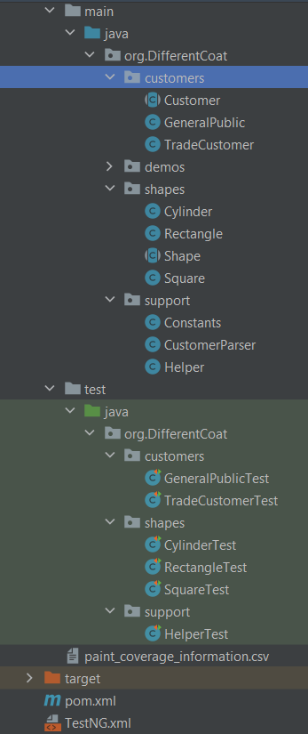By implementing a comprehensive test automation suite with organized and easily maintainable tests, the paint coverage calculation solution can be thoroughly tested and optimized for maximum efficiency and effectiveness.

Displayed in the figure below are the contents of the TestNG.xml file. Although not a mandatory requirement for conducting regression tests via Maven, this file can significantly aid in organizing the test class execution order. It is recommended to run the test classes for "shapes" and "support" first, as they serve as essential dependencies for the "customer" classes to run as expected.

Below is one of the test classes belonging to the test suite. It contains four tests for the rectangle class and will be the third test class ran based on the TestNG.xml file.

After using the mvn test function a regression test is run and all the test classes within the test suite are ran. Below shows the final output of these tests in console.

**AC 7.1: Research and evaluate the advantages and disadvantages of using a test automation framework** – Apply this to rest assured as it is a test automation framework.

Test automation frameworks have become an essential tool for software development teams looking to optimize their testing processes. They offer numerous advantages, such as code reusability, scalability, consistency, accuracy, and faster feedback, which can significantly improve the efficiency and effectiveness of testing. However, like any tool, they also come with their share of disadvantages, which must be carefully evaluated before implementing a test automation framework.

One of the most significant advantages of using a test automation framework is code reusability. This feature allows development teams to reduce the effort required to write and maintain test cases, resulting in faster test case development and execution. Additionally, automated test cases can be easily modified and reused across multiple projects and releases, reducing the time and effort required for regression testing.

Another advantage of test automation frameworks is scalability. As organizations grow, they need to expand their testing efforts to support multiple projects, test cases, and environments. Test automation frameworks can be easily scaled to accommodate these needs, allowing development teams to quickly add new test cases or make changes to existing ones.

Test automation frameworks also provide consistency, which is particularly important for complex applications that require extensive testing to ensure their functionality. Automated tests run the same way every time, providing consistent results and reducing the likelihood of errors or inconsistencies.

Automated tests are less prone to errors than manual tests, making them more accurate and reliable. Automated tests follow a predefined script and are not subject to human error, resulting in more accurate and reliable test results. This helps teams identify and fix issues more quickly, improving the overall efficiency of the testing process.

Finally, automated tests can be executed much faster than manual tests, providing faster feedback on the quality of the application under test. This allows development teams to identify issues and address them more quickly, resulting in faster delivery times and a more efficient testing process.

However, implementing a test automation framework also comes with its share of disadvantages. For example, setting up a test automation framework can be time-consuming and require significant resources. The framework must be configured correctly, and the tests must be designed to work with the framework, resulting in delays in the testing process and increased costs.

Test automation frameworks require ongoing maintenance to ensure that they remain up to date and continue to work correctly. This includes updating scripts to reflect changes in the application under test and addressing issues that arise during testing. Additionally, test automation frameworks can be expensive to implement, particularly for small organizations with limited resources, resulting in a higher upfront cost for testing, which may be difficult to justify for organizations with limited budgets.

Automated tests are not always suitable for all types of testing, particularly those that require subjective analysis or user interaction, limiting the effectiveness of automated testing in certain scenarios and requiring additional manual testing. Finally, automated testing can provide a false sense of security if it is not properly designed and executed, resulting in inaccurate test results.

In conclusion, test automation frameworks offer significant benefits, including increased reusability, scalability, consistency, accuracy, and faster feedback. However, they also come with drawbacks, such as the initial setup time, ongoing maintenance, cost, limited scope, and the potential for a false sense of security. Organizations considering implementing a test automation framework should carefully evaluate these advantages and disadvantages to determine whether it is the right choice for their specific needs and circumstances. A well-designed and properly executed test automation framework can significantly improve the efficiency and effectiveness of testing, resulting in faster delivery times and higher-quality software.

* 1. Create a basic test automation framework for a given application that features reusability of code and low-cost maintenance

Shown in the screenshots is the test automation framework I created for staff api. The figure below shows a screenshot of the test suits project structure. Shown in it is two main packages allTests and apiTestMethods. The all tests package contains four classes each of these containing tests for their respective request type, POST, PUT, GET and delete across these four classes all 5 of the apis functions are covered.

Figure : Above shows the Project structure for the test suite.

PostAPI

This class covers the Put request types. For this API there is only 1 put function add-new-staff-member. This class ensure that this function works expected.

